SET 9 – ONLINE LEARNING ACTIVITY ANALYSIS
Aim
To analyze online learning activities and student performance using histograms, boxplots, scatter plots, and line charts in R.
Algorithm
- Import the online learning dataset.
- Convert Login_Date into Date format.
- Create a histogram of Quiz_Score.
- Create a boxplot of Quiz_Score by Course.
- Create a scatter plot between Study_Time and Quiz_Score.
- Represent Videos_Watched using point size and transparency.
- Calculate the average quiz score for each month.
- Create a line chart to identify the performance trend.
- Display the dataset.
R Program
library(ggplot2)

data <- data.frame(
Student_ID=c("L01","L02","L03","L04","L05","L06"),
Gender=c("Male","Female","Male","Female","Male","Female"),
Age=c(20,22,19,21,23,20),
Course=c("R","R","SQL","R","R","SQL"),
Study_Time=c(3.5,4.2,2.0,5.0,2.5,4.0),
Videos_Watched=c(12,15,8,18,9,14),
Quiz_Score=c(78,85,65,92,70,88),
Login_Date=as.Date(c("2025-01-05","2025-01-05","2025-02-08",
"2025-02-08","2025-03-12","2025-03-12"))
)

ggplot(data, aes(Quiz_Score)) +
geom_histogram(binwidth=5) +
labs(title="Quiz Score Distribution", x="Quiz Score", y="Frequency")

ggplot(data, aes(Course, Quiz_Score)) +
geom_boxplot() +
labs(title="Quiz Score by Course", x="Course", y="Quiz Score")

ggplot(data, aes(Study_Time, Quiz_Score, size=Videos_Watched)) +
geom_point(alpha=0.6) +
labs(title="Study Time vs Quiz Score",
x="Study Time (hrs)", y="Quiz Score")

data$Month <- format(data$Login_Date, "%Y-%m")
avg <- aggregate(Quiz_Score ~ Month, data, mean)

ggplot(avg, aes(Month, Quiz_Score, group=1)) +
geom_line() +
geom_point() +
labs(title="Average Monthly Quiz Score",
x="Month", y="Average Quiz Score")

print(data)

OUTPUT:
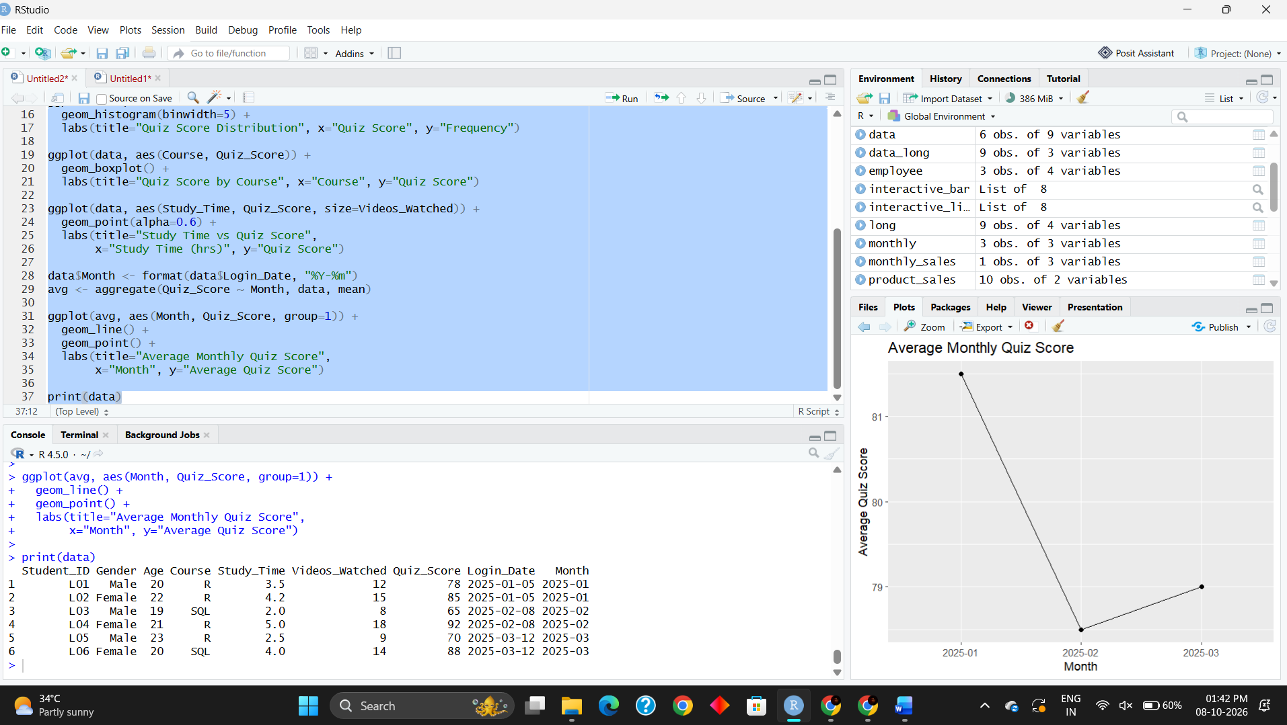
Result
The histogram shows the distribution of quiz scores, while the boxplot compares quiz performance between R and SQL courses. The scatter plot shows the relationship between study time, quiz score, and videos watched. The line chart displays the average monthly quiz-score trend successfully.

